**GUI Version 1.0.0**

The development team designed a Graphical User Interface to give a shape to their thoughts. The GUI is a rough representation of what the development assumed the final product will look like. Designing the GUI helped the development team understand better the need of the project sponsors and get their valuable feedback.

Below is the GUI the development team designed -

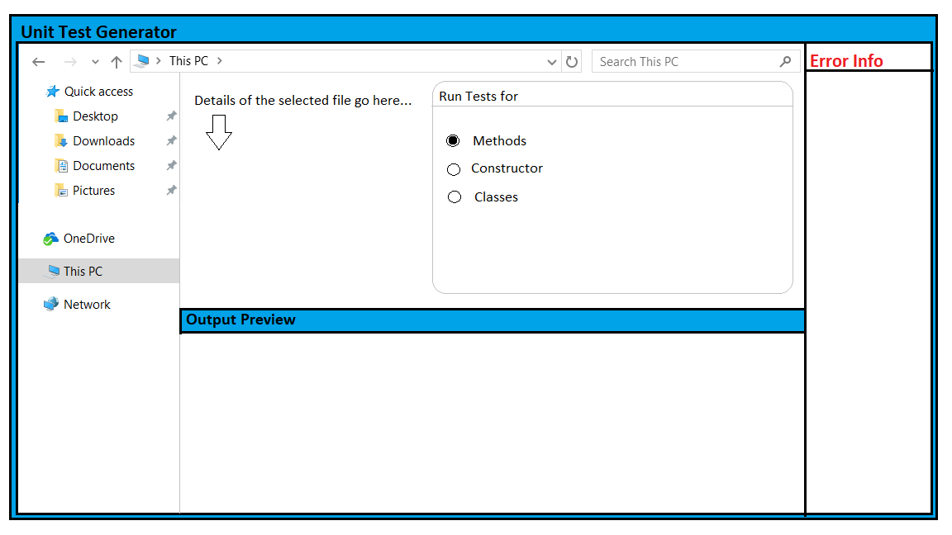

**Tool Used**: MS Paint

**GUI Description**: The GUI consists of a file chooser which will help the user in selecting the file he/she will use. At the bottom there will be an output preview section which will give the user a rough idea of what the actual output may look like. The left side has space for error information which happens when the user hits the RUN button.

**What needs to be improved..**

The GUI is supposed to generate files that will be fed into CPP Unit Lite to carry out testing. Therefor we can completely ignore the “Run Tests for:” column.

The GUI misses a “RUN” button.